# Measurable and Progress from maladaptive behaviors.

|  |  |  |  |  |  |
| --- | --- | --- | --- | --- | --- |
| Maladaptive Behaviors | Baseline Date:2017-07-08to2017-07-09 | Current average per week (3/31/2020) | % of Reduction(BL-average/ BL)*100 | Status | Updated STO (3/31/2020) |
| Disruption | 35 incidents per weeks | 3 incidents per week. | 91% | LTO in progress | Sto1(MASTERED 2018-04-21). Sto2(MASTERED 2018-07-28). Sto3(MASTERED 2018-10-20). Sto4(MASTERED 2019-01-12). Sto5(MASTERED 2019-04-04). Sto6(MASTERED 2019-07-06). Sto7(MASTERED 2020-02-29). |
| Withdrawal of attention | 21 incidents per weeks | 3 incidents per week. | 85% | LTO in progress | Sto1(MASTERED 2018-01-20). Sto2(MASTERED 2018-09-15). Sto3(MASTERED 2019-01-31). Sto4(MASTERED 2019-06-08). |
| Argumentative/Defiant Behavior | 28 incidents per weeks | 4 incidents per week. | 87% | In progress | Sto1(MASTERED 2018-01-27). Sto2(MASTERED 2018-09-08). Sto3(MASTERED 2018-12-01). Sto4(MASTERED 2019-03-08). Sto5(MASTERED 2019-06-29). Currently: STO 6(Initiated 7/1/2019) |
| Task Refusal | 56 incidents per weeks | 14 incidents per week. | 75% | In progress | Sto1(MASTERED 2018-04-21). Sto2(MASTERED 2018-08-18). Sto3(MASTERED 2018-11-10). Sto4(MASTERED 2019-01-31). Sto5(MASTERED 2019-04-25). Sto6(MASTERED 2019-07-27). Sto7(MASTERED 2019-07-27). Sto8(MASTERED 2019-10-19). Currently: STO 9(Initiated 11/1/2019) |
| Rapid eating | 35 incidents per weeks | 16 incidents per week. | 54% | In progress | Sto1(MASTERED 2019-03-08). Sto2(MASTERED 2019-04-11). Sto3(MASTERED 2019-06-22). Sto4(MASTERED 2019-08-17). Currently: STO 5(Initiated 9/1/2019) |
| Impulsivity | 70 incidents per weeks | 40 incidents per week. | 42% | In progress | Sto1(MASTERED 2019-03-22). Sto2(MASTERED 2019-04-18). Sto3(MASTERED 2019-05-18). Sto4(MASTERED 2019-06-22). Sto5(MASTERED 2019-07-20). Sto6(MASTERED 2019-08-17). Currently: STO 7(Initiated 9/1/2019) |
| Total of Reduction (%) | - | - | - | - | 72.7976190476 |

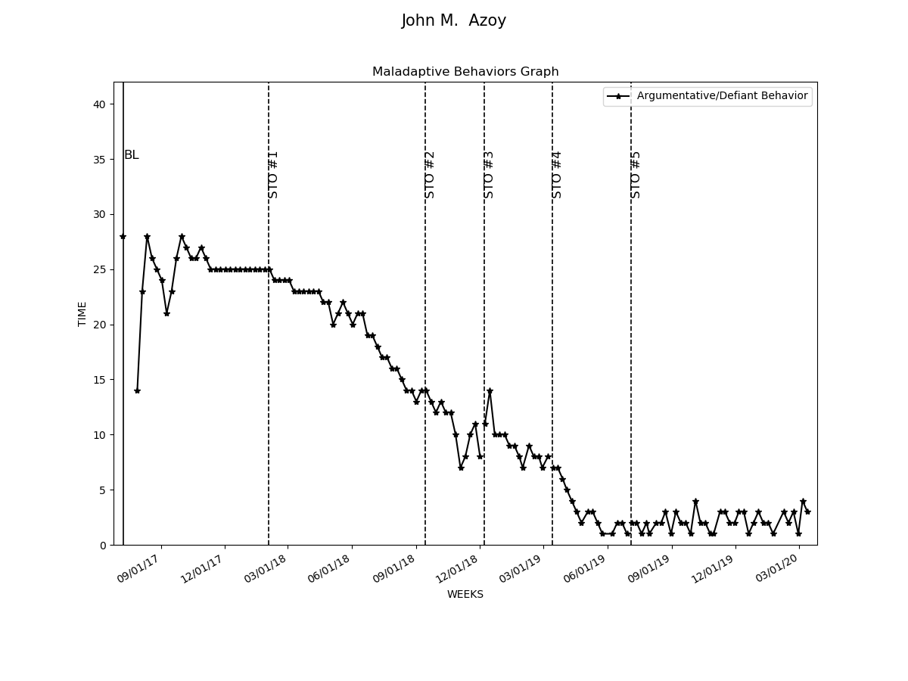

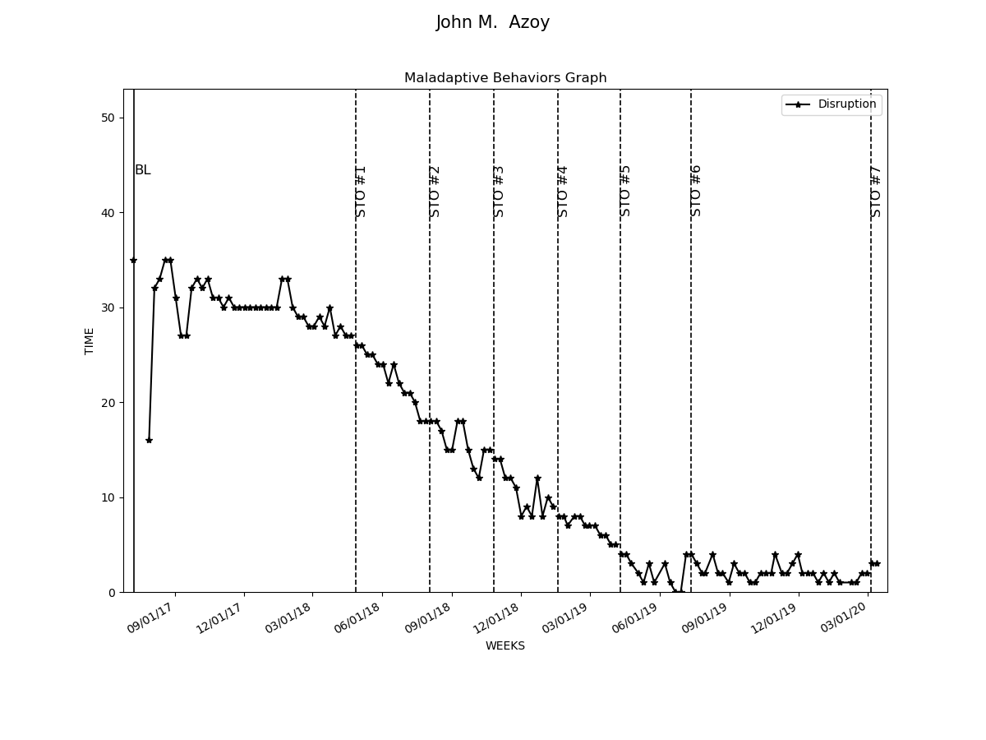

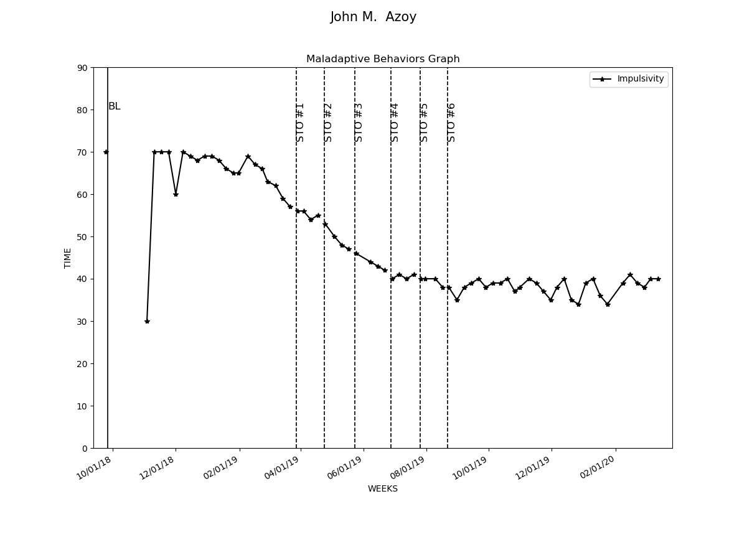

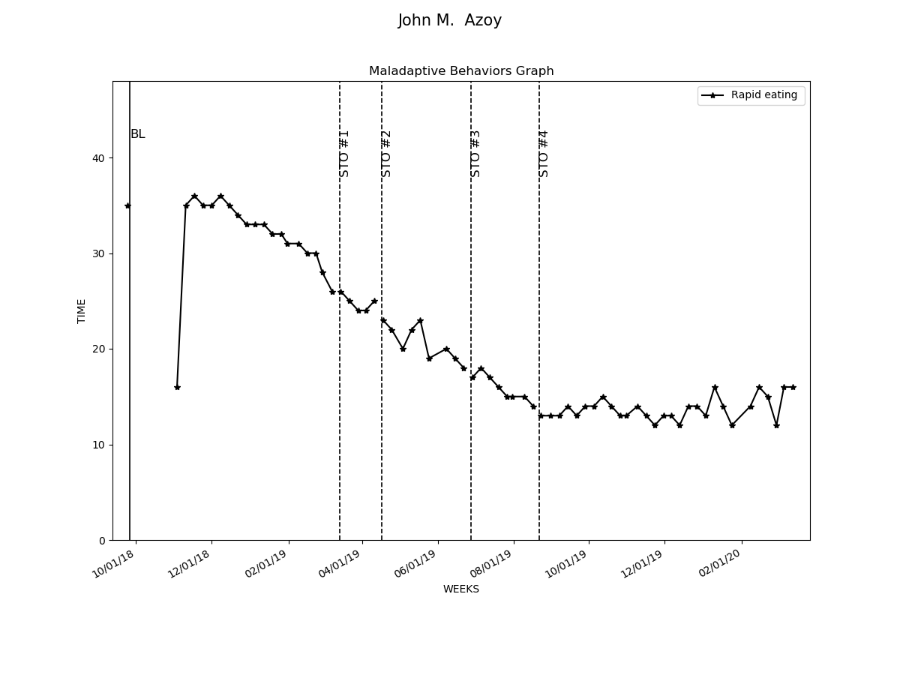

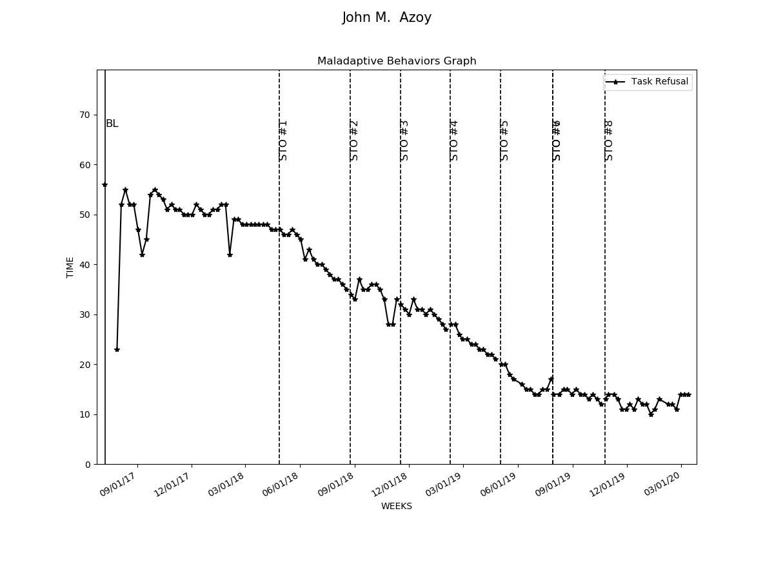

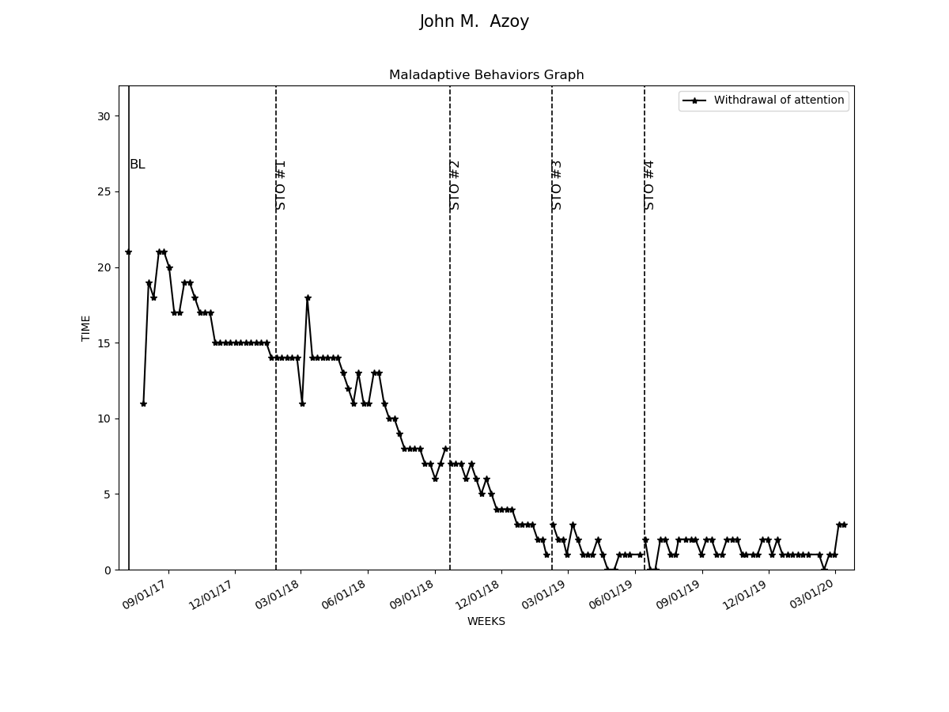

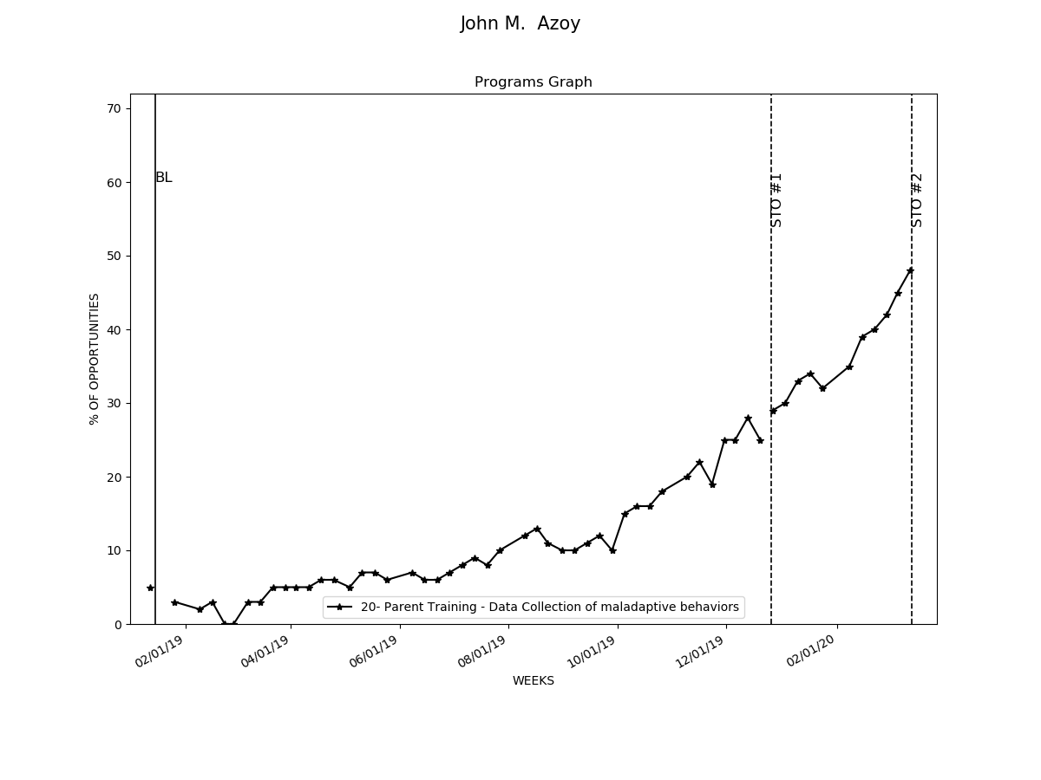

# Graphs Replacement and Interventions

|  |  |  |  |  |
| --- | --- | --- | --- | --- |
| Replacements and Programs | Baseline Date:2017-07-29to2017-08-01 | Current average per week (3/31/2020) | Status | Updated STO (3/31/2020) |
| 14- Respond to stop verbal command | 10% | 49% | In progress | Sto1(MASTERED 2017-12-16). Sto2(MASTERED 2018-05-26). Sto3(MASTERED 2018-06-23). Sto4(MASTERED 2018-07-21). Sto5(MASTERED 2018-11-24). Sto6(MASTERED 2018-12-22). Currently: STO 7(Initiated 1/1/2019) |
| 15- Decreasing distractability | 10% | 50% | In progress | Sto1(MASTERED 2017-12-16). Sto2(MASTERED 2018-05-26). Sto3(MASTERED 2018-06-23). Sto4(MASTERED 2018-07-21). Sto5(MASTERED 2019-02-28). Sto6(MASTERED 2019-07-13). Currently: STO 7(Initiated 8/1/2019) |
| 19- Relaxation techniques | 10% | 43% | In progress | Sto1(MASTERED 2019-04-25). Sto2(MASTERED 2019-09-07). Currently: STO 3(Initiated 10/1/2019) |
| 20- Parent Training - Data Collection of maladaptive behaviors | 5% | 47% | In progress | Sto1(MASTERED 2019-12-20). Sto2(MASTERED 2020-03-13). Currently: STO 3(Initiated 4/1/2020) |
| 21- Parent Training - Generalization of skills | 0% | 44% | In progress | Sto1(MASTERED 2019-12-06). Currently: STO 2(Initiated 1/1/2020) |
| 22- Social Skills- Stating his emotions when there is an aversive stimulus | 30% | 17% | In progress | Currently: STO 1 |
| 23- Social Skills- Accepting when he loses during board games | 4% | 23% | In progress | Sto1(MASTERED 2020-02-08). Currently: STO 2(Initiated 3/1/2020) |
| 24- Social skills- Using idioms during a conversation | 10% | 19% | In progress | Currently: STO 1 |
| 25- Eating slowly | 18% | 20% | In progress | Sto1(MASTERED 2020-02-15). Currently: STO 2(Initiated 3/1/2020) |

